Dashboard Analysis
Team ID | MCA
Project Title | SmartPhone-Usage-Digital-Addiction-Well-Being-Analytics
Maximum Marks | 10 Marks

Creating interactive and visually appealing dashboards involves a combination of thoughtful design, effective use of visual elements, and the incorporation of interactive features. Here are some tips to help you design dashboards that are both visually appealing and engaging for users so take care of below points:
- Clear and Intuitive Layout
- Use Appropriate Visualizations
- Colour and Theming
- Interactive Filters and Slicers
- Drill-Down Capabilities
- Responsive Design
- Custom Visuals and Icons
- Use of Infographics

The Digital Well-Being & Addiction Insights Dashboard provides a simple view of smartphone usage and its relationship with digital well-being.
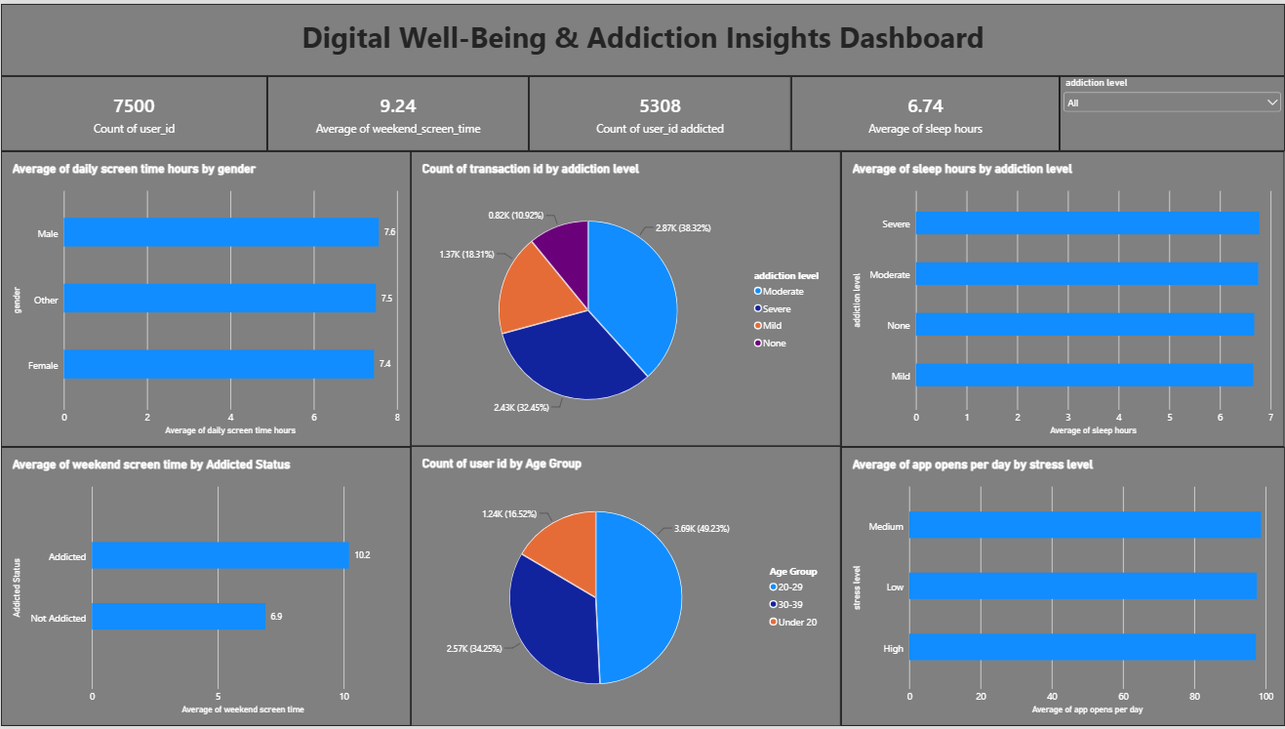

- The dataset contains 7,500 users.
- The average weekend screen time is 9.24 hours, showing that users spend a considerable amount of time on smartphones during weekends.
- 5,308 users are classified as addicted in the dataset.
- The average sleep duration is 6.74 hours.
- Daily screen time is almost the same across genders, with males at 7.6 hours, others at 7.5 hours, and females at 7.4 hours.
- Addicted users have an average weekend screen time of 10.2 hours, while non-addicted users have 6.9 hours.
- The 20–29 age group has the highest number of users, followed by 30–39 and under 20.
- Sleep hours are nearly similar across the different addiction levels.
- The average number of app opens is also almost the same for low, medium, and high stress levels.
The dashboard shows that screen usage is an important pattern associated with addiction status in this dataset. Weekend screen time is noticeably higher among addicted users. However, gender, sleep hours, and stress-level app usage show relatively small differences.

Conclusion
This dashboard helps users understand smartphone usage patterns, identify important trends, and explore digital well-being through interactive Power BI visualizations.

